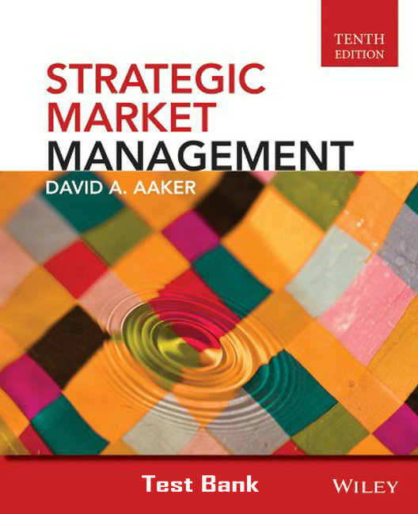
TE NTH EDIT I ON
STRATEGIC
MARKET
MANAGEMENT

10 edition

Test Bank

Test Bank
for Strategic Market Management 10th Edition
David A. Aaker

ESSAY QUESTIONS

1. What is the objective of external analysis? How would you distinguish between an effective and an ineffective external analysis? What would you say would be the most useful way to conduct an external analysis? Why?
-Chapter 1 & 2-

2. Describe and give examples of a well-developed business strategy including the four characteristics.
-Chapter 1-

3. Discuss the advantages of a customizing rather than a standardizing marketing program in the context of a global strategy. When would customizing make sense?
-Chapter 13-

4. Consider the implementation problems of merging Sears and Walt Disney. What synergy would you expect? How could you make sure that it materialized?
-Chapter 7 & 16-

5. Describe scenario analysis using one of the cases discussed in the course as a vehicle to illustrate. What implementation problems would you expect if scenario analysis were to be adopted at Apple Computer?
-Chapter 5-

6. American business have been accused of being short-sighted, looking at short-term financial performance instead of taking a longer-term view. What can a manager do to make sure that he or she is managing for the long term? How would you go about advising a department store to generate indicators of long-term success? Be specific.

7. What are assumptions underlying the growth-share matrix? When are these assumptions likely to hold? What is the historical contribution of the growth-share matrix?
-Chapter 15-

8. Discuss the considerations involved in making the decision to expand or broaden the product line.
-Chapter 13-

9. Describe the distinctions between strategic commitment, strategic opportunism, and strategic adaptability.
-Chapter 7-

10. Describe and illustrate the following terms:
-Scenario analysis - chapter 5
-Strategic uncertainties – chapter 2
-Synergy – chapter 7&16
-Strategic opportunism – chapter 7
-Strategic drift – chapter 7
-Key success factors – chapter 4&7
-Experience curve – chapter 8
-Silo barriers – chapter 16

11. You have been given the task to evaluate a market opportunity for a firm. Give specific examples of the dimensions you would use to determine the attractiveness of a given market.
-Chapter 15-

12. Discuss Competitor Analysis. In your discussion include the following: the objectives of competitor analysis and the elements of competitor analysis. You should use information from the course including articles, cases, and textbook material to support your answer.
-Chapter 3-

13. Discuss Environmental Analysis. In your discussion include the following: the objectives of environmental analysis; the dimensions of environmental analysis; and how to deal with strategic uncertainty. Use information from the course including articles, cases, and textbook material to support your answer.
-Chapter 5-

14. What at the payoffs to creating a new business? What are the risks?
-Chapter 13-

15. Discuss Internal Analysis. In your discussion include the following: the objectives of internal analysis; the benefits of conducting an internal analysis; and the elements of internal analysis. Use information from the course including articles, cases, and textbook material to support your answer.
-Chapter 6-

16. Discuss the concept of customer value proposition and give examples.
-Chapter 8-

17. How could you energize a business? Illustrate your answer.
-Chapter 11-
19. What role does innovation have in strategy making? Give examples of firms who have a history of doing well with innovation and discuss the impact that has had on them.
-Chapter 1, 5, 11, & 13-

20. What is the innovator’s advantage? How can a firm enhance the chances that the innovator advantage will materialize?
-Chapter 13-

OBJECTIVE QUESTIONS

Note – These objective questions cover the material from the book. In general, a false answer is markedly at odds with material in the book. However, it may not be at odds with other written material. Therefore, it is important to position these questions as a test of a student’s competence with the book material.

Chapter 1 – Strategic Market Management: An Overview
.
1.1
Five management tasks used to develop strategic competencies do not include the following:
a. Strategic analysis
b. Manage multiple business units
c. Identify competitors
d. Develop a sustainable advantage
e. Develop a growth platform
Answer: c. Identifying competitors is valuable but not one of the 5 management tasks.

1.2
The book suggests that many markets are dynamic and require new strategic models.
Answer: False—the book asserts that all markets are dynamic.

1.3
To develop a sustainable competitive advantage (SCA) in dynamic markets, a company must create multiple business units.

Answer: False. There are two routes to creating SCA’s, developing assets and competencies and creating and leveraging organizational synergies between multiple business units.

1.4
A business is generally an organizational unit that has a distinct business strategy and a manager with sales and profit responsibility.

Answer: True.

1.5
Synergy occurs when two businesses can reduce costs by sharing some asset such as a sales force or logistics system.
Answer: True.

1.6
A strategy should only involve one value proposition – otherwise chaos will occur.
Answer: False. Most successful strategies involve more than one – for example, a customer value proposition that involves innovation and customer intimacy such as Virgin Atlantic Airways.

1.7
A strategic market management system will have more value for an organization that is not engaged in complex markets with multiple channels and regional variation in channels and products.
Answer: False. A strategic market management system is designed to help a company (complex or not) to deal with the rapid changes that can occur in a firm’s external environment.

1.8
The elements of strategy can be capsulated into four core elements--the product-market investment decision, functional area strategies, the customer value proposition, and the sustainable competitive advantage.
Answer: False the four elements are: 1) the product-market investment strategy 2) the customer value proposition, 3) assets and competencies and synergies, and 4) functional area strategies. So while a sustainable competitive advantage is the goal of a business strategy it is not one of the elements that make up a good business strategy.

1.9
A strategic competency is what a business unit does exceptionally well, such a manufacturing, promotion, distribution, etc. which has strategic importance to the business.
Answer: True. This is the definition of a strategic competency. .

1.10
According to the book, strategic marketing management has six objectives which include all except one of the following:
(a) Precipitate the consideration of strategic choices.
(b) Contribute to the bottom line success of the firm.
(c) Force a long-range view.
(d) Make visible the resource allocation decision.
(e) Provide methods to aid in strategic analysis and decision-making.
Answer: B. There is nothing that will guarantee the success of a business. In fact, it is interesting to discuss that a strategy is evaluated after implementation; that is when it is known whether a strategy is successful or not. .

1.11
The four elements of a business strategy for a firm are the product-market investment decision, the functional strategies and program, the customer value proposition, and the __________ and _________.
Answer: assets and competencies. .

1.12
The scope of a business is defined by the products it offers and chooses not to offer, by the markets it does and does not seek to serve, by the competitors it chooses to compete with or to avoid, and by its level of vertical integration.
Answer: True. This is the definition of a business scope.

1.13
Strategic marketing is involved in making decisions, some of which include investment decisions. Of the following which is not an investment decision:
(a) Invest for growth
(b) Milk
(c) Maintain
(d) Liquidate
(e) Innovation
Answer: E. Innovation is a strategic option. .

1.14
An external analysis includes the analysis of the customers, the competitors, the markets/submarkets and the environment.
Answer: True.

1.15
According to the book, customer analysis involves identifying the organization’s customer segments and each segment’s motivations and priority needs.
Answer: False. See Figure 1.3.

1.16
Strategic market management is a system designed to help management both precipitate and make strategic decisions, as well as create strategic visions.
Answer: True. This is the definition of strategic market management.

1.17
Marketing’s role in strategy includes being the primary driver of strategic analysis.
Answer: True.

1.18
The strategic plan should be developed annually.False. It should be continuously refined.

